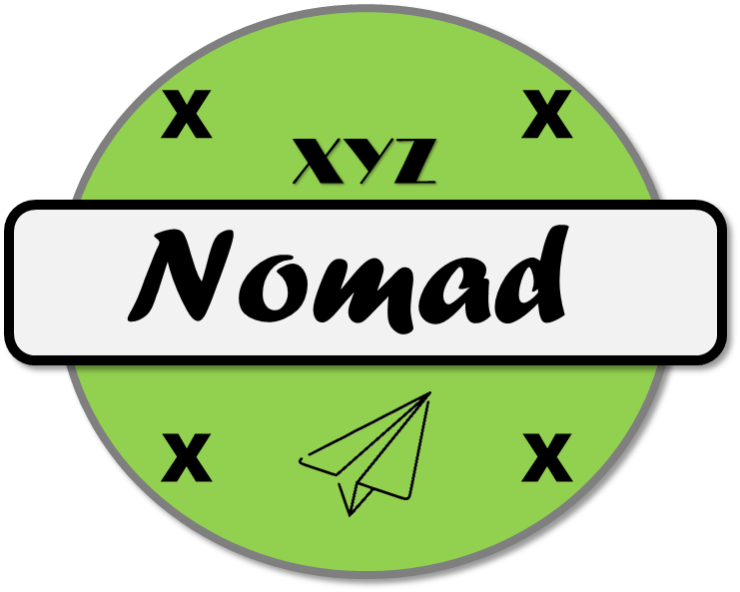

Legacy Flight Performance Testing

30 July 2019

Version 1.5

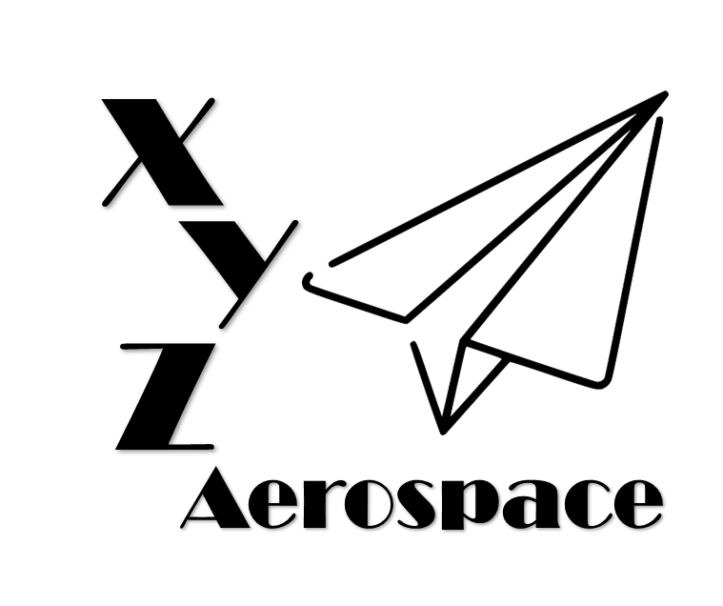

645 Colonel Glenn Blvd

Dayton, Ohio

DISCLAIMER: This document has been produced to support training and experimentation ONLY. It does not represent any system, real or planned. No United States Government resources were used to produce this document.

**THIS PAGE IS INTENTIONALLY BLANK**

Contents

1. Introduction 5

2. Flight Performance 5

1. Maximum 5

3. Control Communications 5

**THIS PAGE IS INTENTIONALLY BLANK**

1. Introduction
2. Flight Performance
   1. Test 1
      1. Maximum Airspeed

Passes

* + 1. Maximum Altitude

Passes at MSL, not AGL… Make them do the calculations

* + 1. Time to Climb

Passes

* + 1. Mass Properties
  1. Test 2
     1. Endurance

Passes, but has extended battery option

* + 1. Mass Properties
  1. Test 3
     1. Pitch/Roll/Yaw

Passes

* + 1. Speed (vertical, lateral)

Passes

1. Control Communications
   1. Test 1
      1. Control Link Operational Range

Passes

* + 1. Lost Link Detection

Passes

* + 1. Lost Link Behavior

Hovers

1. Navigation
   1. Test 1
      1. Stationary Error

Fails

* + 1. Moving Error

Fails